

Operation Handbook

Still Updating…

Internal Use Only

**Welcome to Universal Processing Operation Team!**

**Contents**

**General Info of Industry**……………………………………………..…….………………………… 3

**Operational Skills & Procedures**………………………………………………………………..….. 6

**Change Request Issues/Ticket**s …………………………………………………………...……….21

**Deal submission in OpenERP**…………………………………………………………..…………. 26

**Transaction Related Issue**……………………………………………..…………………….………37

**Risk & Funding(ACH)**...............................................................................................................42

**Terminal Issues & Requests**…………………………………………….…………….…………….46

**Appendix**…………………………………………………………………...…………………………..50

**General Info of The Industry**

**What is Interchange?**

Interchange fees are transaction fees that the merchant's bank account must pay whenever a customer uses a credit/debit card to make a purchase from their store. The fees are paid to the card-issuing bank to cover handling costs, fraud and bad debt costs and the risk involved in approving the payment.

**Interchange Plus vs Flat Rates**

**Interchange Plus**, as known as IC+ or Cost Plus, is a fee structure wherein we mark up a certain percentage of total volume on top of the pure cost as a part of profit. There are thousands of cards on the market with different interchange rates. So, the monthly fees or rate on statements may be little different.

**Flat Rate,** or Fix Rateis the fee structure wherein the percentage of monthly volume merchants have to pay ( total rate we charge) can cover at least the all pure cost. Therefore the total percentage on the statement won't change over time. And It is easy to cause negative profit if the rate was set too low.

**Discount Types-Monthly Discount vs Daily Discount**

**Monthly Discount**, Merchant will have a one time payment of the total amount of the Interchange and monthly fees at the beginning of next month.

**Daily Discount,** Merchant will pay the interchange with our profit every day. And have another one time payment of total monthly fees at the beginning of next month.

**Electronic Draft Capture, EDC**

EDC is the technology that retrieves the customer’s banking information and captures the draft, or the amount due. Once the funds are secured, the money transmits to the merchant’s account.

**EMV**

EMV is a payment method based on a technical standard for smart payment cards and for payment terminals and automated teller machines which can accept them. EMV stands for "Europay, Mastercard, and Visa", the three companies that created the standard.

**EMV cards** are [smart cards](https://en.wikipedia.org/wiki/Smart_cards), also called chip cards, integrated circuit cards, or IC cards, which store their data on [integrated circuit](https://en.wikipedia.org/wiki/Integrated_circuit) chips.

**Cash Discount Program**

Cash Discount Program(CDP) accounts will be flat rate accounts with a daily **discount.** The idea is to pay cash and save, saving the card processing expenses. Credit card processing companies will help merchants set up the discount rate on terminals and deduct the discount fee from the batch total everyday. Our suggested discount rate is 3.95%, therefore to match with the terminal, our backend needs to collect a 3.80% flat rate as daily discount.

Front-backend Discount Equation:

$χ$* Terminal % = $χ$ (1+Terminal %)*Backend%

e.g. : $100 *3.95%= $103.95 * 3.8%

$χ$ is the cash(base) price. And the terminal-backend rate combo can be different, to check the terminal-backend rate combo, please use [CDP Calculator](https://docs.google.com/spreadsheets/u/0/d/1Ze2pEsqZmlFx5BmwKBVQJIBb2xPkPZXc_bOBwridUuQ/edit) in Google Drive.

**Transaction Circle and the MID**

Universal Processing is a credit card processing company. UP works with Acquiring banks, known as **“Backends”** to board merchant processing accounts. And acquiring banks working with Settlement networks to process and settle transactions.

Following is the circle of the credit card payment.

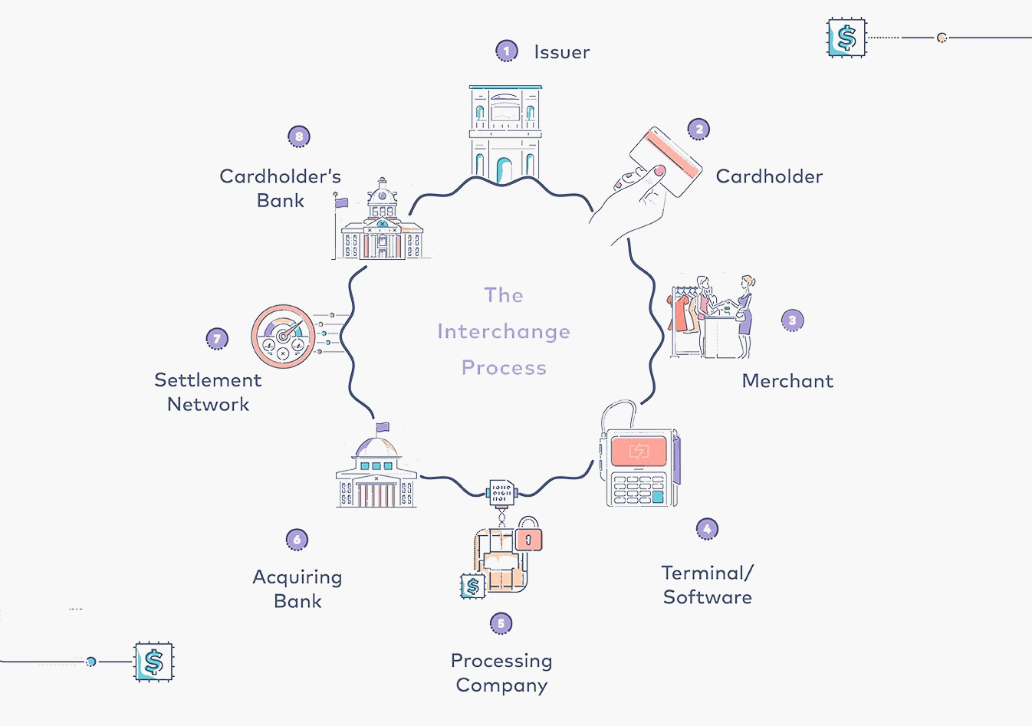

*UPers mostly will work in between step 3-7

We currently work with two settlement networks(Acquirer Processors)

First Data(FD), and Total System Services(TSYS)

Our partner companies, the Acquiring Banks, are using their services.

Here are the names of our backend and the banks:

Priority Payment System(PPS) work with Wells Fargo Bank(FD) Synova Bank(TSYS)

Quantum Epay(QEP )work with Fifth Third Bank(TSYS)

Corvia Payment work with MVB bank(TSYS)

Cardconnect(Defyne payment) work with Wells Fargo Bank(FD)

Signature payment*(High Risk Channels)

All our accounts boarded to the acquiring banks will be assagin a unique Merchant ID number starting with the BIN number, as known as MID. To quickly differentiate the backends, we can compare the first four digits of MID， the BIN number, to get the idea of the merchants' backend belongings.

Our uP’s BIN is 7522. Therefore，our **uP MID will start with 7522 through Esquire Bank**

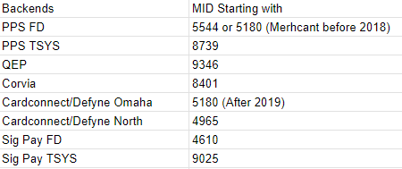

**PPS FD**  Wells Fargo

**PPS TSYS** Synovas Bank

**QEP** Central Bank

**Corvia**  MVB Bank

We also have：MID starting with 5563 is Merchant Industry (MI)

MID starting with 6755 is Cygnus Payment.

MID starting with 6158 is QEP Fresno First Bank(High Risk)

MID starting with 5482 is Paysafe, no portal.

MID starting with 3899 is Vimas, PPS

MID starting with 2130 is Sig Pay(High Risk)

This information is giving us the idea to call or open the correct backend portals for help!

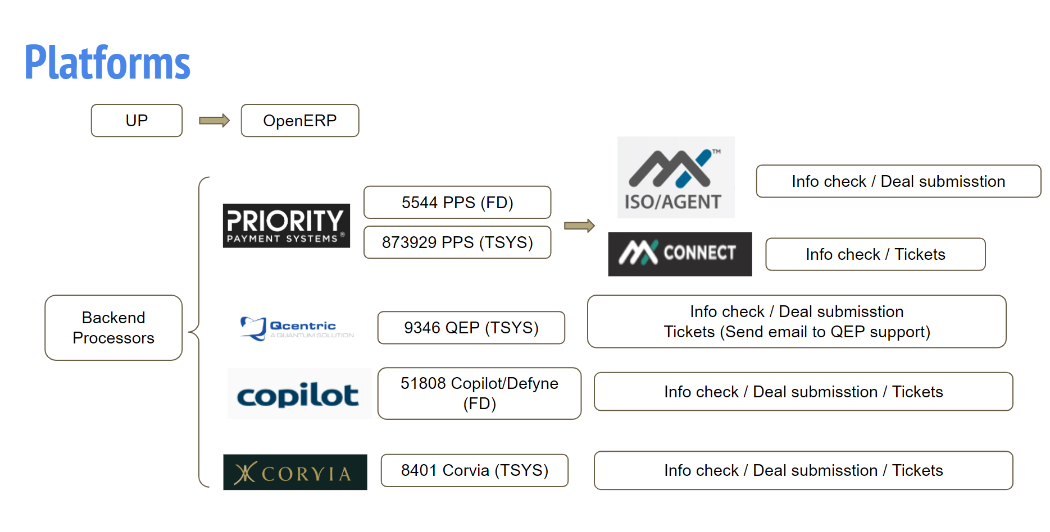

| **Backend Portals List** | | |
| --- | --- | --- |
| Portal Names | Functions | Links |
| **uP BIN** | **All in one** | **https://up.isoaccess.com/index.php** |
| PPS ISO Agent | Legacy MID Checkup | https://mxisoagent.com/mx/Dashboard/Dashboard.aspx?p=Dashboard |
| PPS MX Connect | Newapp, Day to Day | https://mxconnect.com/ |
| QEP Qcentric | App, Trans, ACH | https://quantum.merchantportfoliomanager.com/ |
| Corvia Portal | App | https://portal.corviapay.com/signin |
| Corvia Elevate | Trans, ACH | https://portal.elevateqs.com/login |
| Cardconnect CoPilot | All in one | https://cardconnect.com/ |

Major Phone Calls’ List.

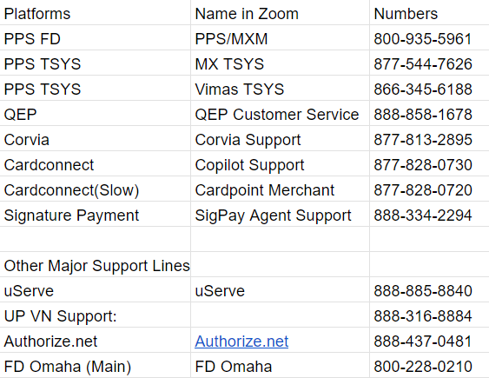

**Operational Skills & Procedures**

**Customer Phone Call Skills**

As you know, we are taking care of general customer service and cooperating with internal operations. The phone call is an important method in your professional daily life.

Here is a standard phone call communication that can help you to have polite, professional and eﬀective phone calls.

**1. Greeting**

The greeting and the speed that the phone is picked up can determine the customer's overall impression of the experience.

In many cases, if the phone rings more than four times, it is too long; for the caller, boredom starts to set in. On the other hand, people who pick up almost instantly may startle the caller. Try to ﬁnd a middle ground such as picking up after the ﬁrst ring, but before the second.

From the phone call greeting, we should let the customer feel that we can help them sort out a problem.

**2. Consider the tone and speed of your voice.**

As a professional customer service, the tone, and the speed of your voice also should be certain. Clear, being sure about what you are saying and controlling the speed of your words is required. Consider what things really annoy you--it might be speaking too fast, too slowly, in a very loud or quiet voice, or someone who places too much emphasis on certain tones (such voices that may be described as too "bubbly" or "bouncy"), or tones that are very ﬂat, which suggest disinterest in the caller

**3. Consider the middle and end of the call--both the middle and end are crucial.**

Many perfectly good calls have been ruined by a bad ending, much like an excellent meal ruined by poor service at the cashier's desk when leaving--just one small thing that is wrong anywhere along the course of the meal can cause disappointment with regards to the whole event.

A near-automated "Have a nice day" ﬁnale can turn people oﬀ with regards to having anything to do with your company, because if the words lack sincerity it implies the customer service contact likewise has no sincerity.

Also, consider the overall length of the call. If the customer has in-depth and complex queries that take a while on the phone to sort out, then adequate time should be given to the customer. At the other end of the spectrum, rushing a call or limiting call time can make the other person feel like they aren't important, whereas making the call much longer than necessary can also become an issue.

We must take control of the call and make sure the customer’s issue can be ﬁnished eﬃciently in the limited short time. Your knowledge of their industry and product is important in the role that client support plays as a consultant.

**4. Ensure that the people who are on the phone actually know what they're talking about.**

You should lead the customer making it clear when it is appropriate to recommend referral of the caller to someone who can help as soon as possible.

For individual cases, you can consult your colleague who has more experience in a certain area. Quite often you can ﬁnd out very quickly what could be a cause for concern.

**5. Examples**

Greeting:

Hello Universal Processing. How can I help you?

您好，环球商务。请问有什么可以帮您？

May I know / Could you please tell me the last 6 digits of your MID?

请问您的MID后六位数是多少？

Retrieval Card Information:

Excuse me, are you the owner of the business?

请问您是店主本人吗？

“Yes”

—Please don’t hang up the call and bear with me a moment I will call our back-end system to help you to retrieval the full cc# info.

The customer service rep will verify your last 4 digits of SSN. Please wait.

—请您稍等不要挂电话，我这边需要帮您连到后台客服帮您找回卡号信息。稍候后台的客服人员会跟您确认身份信息（社安号后四位, EIN 后四位）。请稍等。

“No”

--I am sorry we can’t help you if you don’t have the owner online. Please let the owner call us back. (Or if you know owner’s full name & last 4 digits of SSN(Or Last 4 of EIN), that will be ﬁne)

—实在抱歉如果您不是店主，我们暂时不能帮您找回卡号。请您让店主有时间再给我们来电。（或者您如果有店主的全名以及社安号后四位 或 EIN 后四位，也是可行的）

Account Closure

--Hello Sir/ Madam, are you the owner of the business? Based on company policy, we only can talk to the real owner of the business about any info related to the closure.

—您好，请问您是店主本人吗? 根据公司规定我们只能和店主本人沟通任何有关关户事宜。

“No”

--Sorry, we are not allowed to talk to you regarding closure information. Please let the owner contact us. Thank you.

—抱歉，我们不能向您透露任何相关账户信息。请您通知店主亲自联系我们。谢谢。

“Yes”

--May I know the reason why you want to close the account with us？

—请问您的关户原因是什么？

Defense, convince the merchant, try your best to save this account.

--Thank you so much for your corporation. We will contact our merchant success department, and advise them to contact you back in order to help with closure progress. Could you please leave a number so we can contact you at the ﬁrst time?

—感谢您的配合。您的意见我们已经收到。我们会马上联系关户部门，并通知他们尽快联系您帮您处理关户事宜。请问稍候哪一个电话方便联系到您?

Someone is calling to look speciﬁc person to get the call:

Excuse me, may I ask who’s calling? / May I have your name?

请问您是来自哪一家公司？怎么称呼？

May I also ask what it's call regarding?

请问您找他有什么事情？

Do not transfer the call to your superior or your colleague easily.

Always conﬁrm with others ﬁrst to check if the call is really necessary to transfer to a speciﬁc person to handle and the person is available.

If the person conﬁrms “yes you can transfer to me”

--Hello Sir/Madam, please give me one second. I will transfer to XX.

--您好，请您稍等我帮您转接给XX.

“No.”

For merchant’s call:

Hello Sir/Madam, I am sorry she/he is unavailable right now. I also can help you. May I know your concern/issue/problem? Or if you insist on speaking to her/him, I can help you to leave a message. Which number can we call you back?

您好，实在不好意思他/她现在正忙。我也可以帮到您。请问您有什么问题？如果您一定要找XX，我可以帮您留言。请问稍候那一个电话方便联系到您？

Ending:

--Is anything else I can help you with?

—请问还有什么可以帮您？

--Thank you for calling Universal Processing. Have a nice day!

--感谢您的来电。祝您生意兴隆，生活愉快!

**Calls that Request related to the third party (Auth.net, Clover, Menusifu etc.)**

Please advise merchants to write down the third party direct line. Warmly transfer (Greeting the Merchant and Blind transfer.) the call to the third party CS line If M mentions need language services. The CS member needs to be the interpreter.

### 

### 

### **Email Communication & Skills**

For email communication, we must be professional, polite and efficient.

Before sending the email, please make sure to set up your signature with the UP logo correctly. (Location May Different)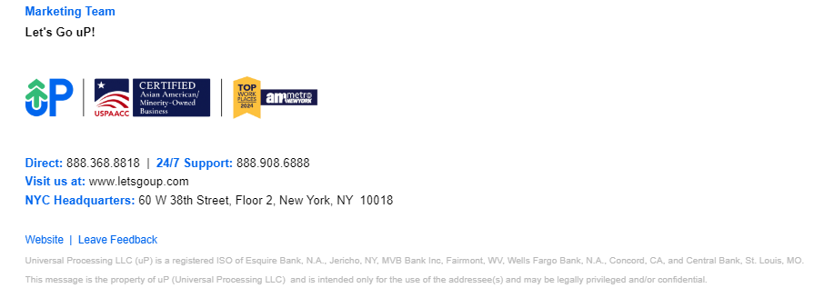

**Writing an Email:**

**1. Email Subject Format:**

[Issue Type]DBA+MID

For example,

[Closure Request] Starlight Smoke Shop934600000091744

## [Terminal Request] Summit Nails934600000108399

**2. Being greeting**

Always open your email with a greeting. You can simply say, **“Hi Bufan”**. If you don’t know the name of the person you are writing to, please use: **“To whom it may concern”** or **“Hello Sir/Madam”**. If you are writing the email to a general department, you can say, **“Hello Team”**.

**3. State your purpose**

If you are starting the email communication, it may be impossible to include a line of thanks. Instead, begin by stating your purpose. For example, **“I am writing to inquire about**

### **…” or “I am writing in reference to …”.**

Make your purpose clear early in the email, and then move into the main text of your email. Remember, people want to read emails quickly, so keep your sentences short and clear. You’ll also need to pay careful attention to grammar, spelling and punctuation so that you present a professional image of yourself and your company.

**4. Add your closing remarks**

Before you end your email, it’s polite to thank your reader one more time and add some polite closing remarks. You might start with **“Thank you for your patience and cooperation”** or **“Thank you for your consideration”** and then follow up with, **“If you have any questions or concerns, don’t hesitate to let me know”** and **“I look forward to hearing from you”**.

**5. End with a closing**

The last step is to include an appropriate closing with your name. **“Best regards”**, **“Sincerely”**, and **“Thank you”** are all professional. Avoid closings such as **“Best wishes”** or **“Cheers”** unless you are good friends with the reader. Finally, before you hit the send button, review and spell-check your email one more time to make sure it’s truly perfect!

**6. Thank the recipient**

**\*Filter the email by Labels.**

In Order to reduce the chance of missing important emails among tons of new emails, we’d better create the Email label with a filter for the important category such as personal email, New app, etc.

Here are the steps for labels and filters

1. Create a Label with the Color in your Working Gmails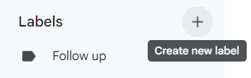

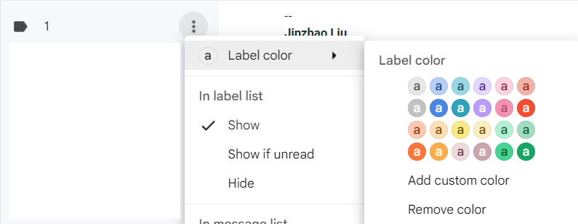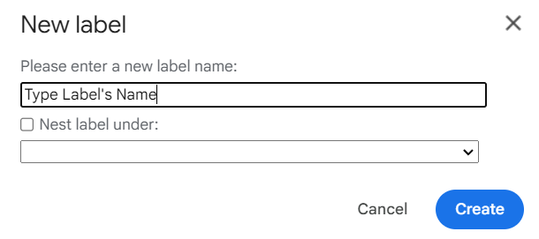

2. Search the Email address that needs to be labeled and Click “Show search Option“ and choose Create filter.

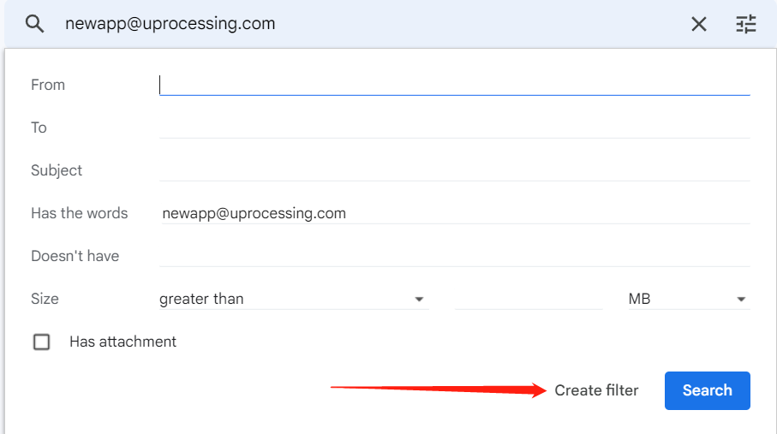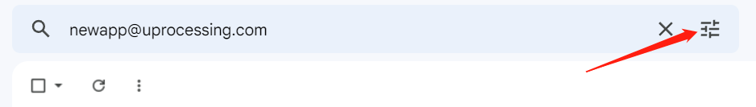

3. Check Apply the label and choose the label that needs to be added. Then click the “create filter” at the right bottom corner.

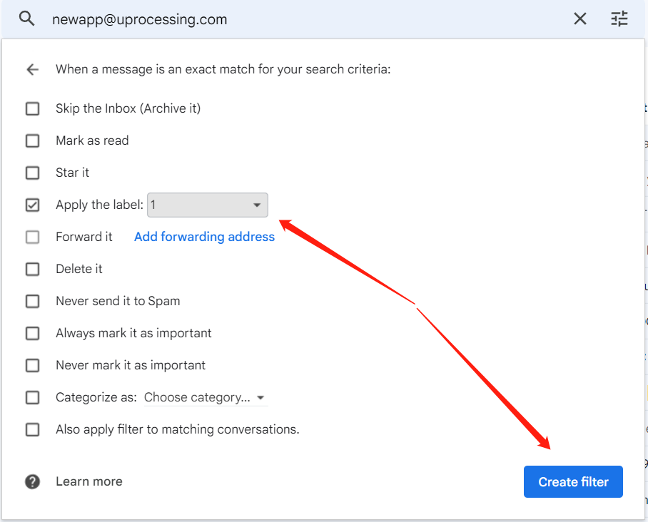

Then we finished!

**OpenERP and Ticketing System Tour**

OpenERP is our day to day using ERP system, following is the tour guide of this system.

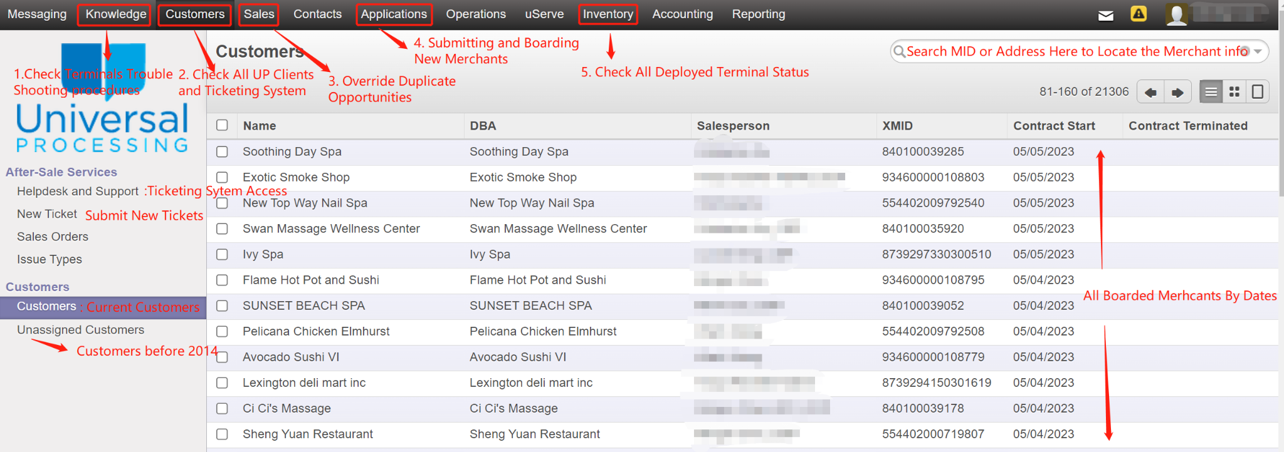

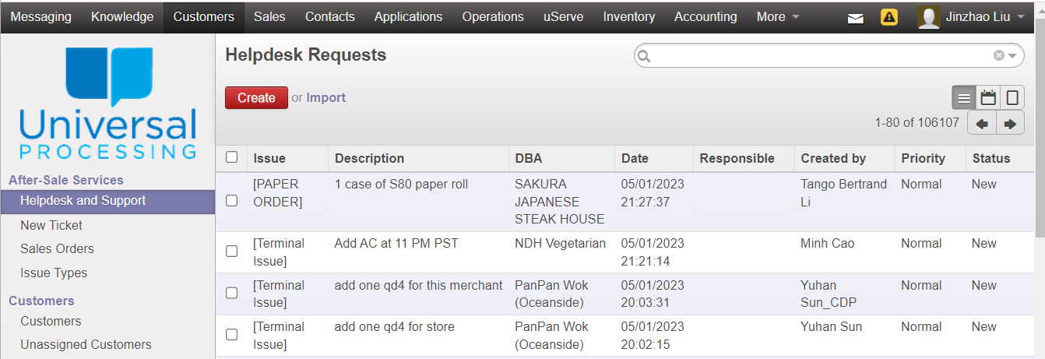

**\***Ticketing system location in OpenERP

**Ticket Types for OP Team to Submit**

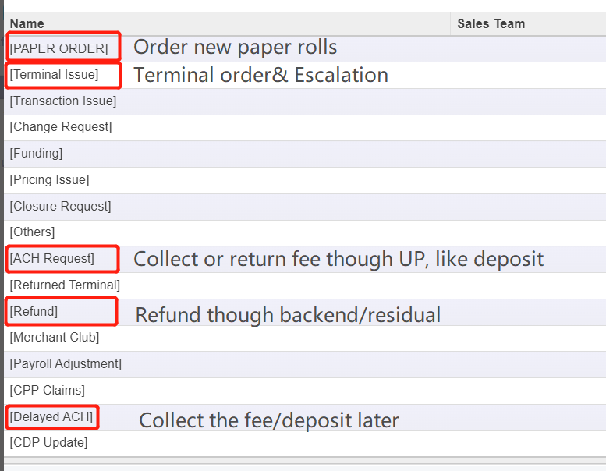

* Ticket type list

Our OP team usually creates: PAPER ORDER. TERMINAL ISSUE, ACH REQUEST, REFUND AND DELAYED ACH.

**All other types were designed for the sales team. CS members should help the sales team to resolve the tickets per request.**

**\*CS members who have terminal access need to assist deployment handling the terminal issue tickets.**

**\*CS members who have paper order access need to handle the paper order tickets per schedule. Appendix1\***

OpenERP Ticket Introduction

1.Refund Ticket

All the processing fee charged by backend platforms, which is shown on the monthly statement. These refunds include PCI-non-compliance fee, monthly minimum charge, monthly fee, MX insight fee, chargeback/ retrieval fee, etc.

2.ACH Ticket

All the fees charged by UP directly, including terminal deposit (refund), MC(refund), paper order,

terminal swap (Shipping and Handling), POS charge, non-returned terminal recoupment fee(refund) and some special reimbursement to M.

3.Terminal Issue Ticket

All the issues regarding terminal, swiper, online gateway, etc. All the stuﬀ you want to communicate with the tech team, including changing terminal delivery address, rush terminal, returned terminal, etc.

4.Paper Order Ticket

All regular paper orders needed. Please make sure if the paper size is regular. The POS paper order needs to be checked with a supervisor.

5.Change Request Ticket

All the change requests related to the merchant’s account. Such as: location change, phone# change, TIN invalid etc. Most of the change request tickets need to attach the merchant signed Change Request Form.

6.Funding Ticket

All of the issues related to the bank account. New bank account update/change, Next Day Funding change, fund hold issue etc. Bank account change request needs to be attached to the owner's signed change request form.

7.Closure Ticket

All the accounts closure requests. Need owner signed closure form attached.

8.Pricing Ticket

All the requests related to pricing. Included but not limited to increase/decrease pricing, change pricing model, add speciﬁc pricing etc.

9.Transaction Issue Ticket

All the requests & concerns related to the transaction. Included but not limited to transaction veriﬁcation, transaction review etc.

10.Payroll Adjustment Issue Ticket

Sales agents pay for the merchant with their payment. Such as pay the terminal deposit for the merchant, pay the paper order fee, or pay the refund amount etc.

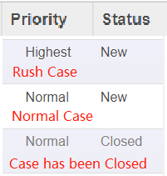

How to process Tickets

1.In Helpdesk and Support. Select the case with Status“ New.”

2. Click “Open”

3. According to the request, finish the task

4.Back to ticket, Click “Close” on the ticket.

**Merchant Club Related Issue**

Merchant Club is a program for merchants to get a deduction on terminal deposit up to $250 and get the free terminal paper(2 1/4''). The Cost is $23.88. per month

**MC Types and Difference**

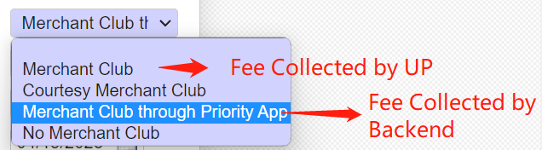

**Paper Order:**

**Paper size:**

Pax A920 A920 pro, small paper roll, 2 1/4 \***50ft**\* 50 rolls

Pax S80 A80, Dejavoo Series, VL Series,VX 520,Clover mini Clover Flex, regular paper roll, 2 1/4 \***85ft**\* 50 rolls, should cover 3000 transaction

POS Printer, Clover Solo, Duo, Station, big paper roll, 3 1/8 *119 ft* 50 rolls

**Procedures of Paper Ordering:**

1. Double check if M is in MC, if not, M need to pay for paper order, usually $30 per case

2. Conﬁrm the shipping address, especially if account has history of lost package

3. Make sure it’s a regular order.

Sometimes M calls in for orders because they thought they didn’t receive the last order. In this situation, please provide the tracking info and help M track with the last paper order. Usually, if the last order time is 1-2 months ago, no need to check more info. If not, please make sure M needs that much paper. Please check in the backend portals for the monthly transaction total and rolling proﬁtability to decide.

Usually 1 case of paper per call, if M insists, follows the previous ticket’s number. New merchant Special Cases(More than 2 or free POS paper order) have to be approved by the Managers before submission.

4. If a merchant has a special paper order request, such as POS paper order, please explain to the merchant it will cost $68/case. No matter if it is in MC or not. MC will not cover any POS paper rolls Size: 3/1/8 inch

For CS with access to deal with paper order tickets Please check * **Appendix1**

**MC cancellation/refund**

**Please try to explain that the MC fee is a part of the monthly fee. Proceed following steps if the merchant insisted.**

1. Please explain MC charge ($9.95, or $14.95 after 11/16/2015, or $23.88 after 08.01.2023), including free paper order, Waive up to $250 deposit of a terminal under $350, free replacement for covered terminals.

2. If M wants to waive MC charge, terminal deposit is required for all existing terminals

3. Make sure M didn’t order paper in recent 3 months (for $9.95 accounts) or recent 2 months (for $14.95/23.88) before canceling MC. Otherwise, we need to charge twice/ three times MC until we can cancel MC. Or M can pay for the last paper order to cancel MC immediately.

4. If M asks for MC fee refund, we can refund up to 3 months, under the situation that M never uses MC service.

**Terminal Deposit**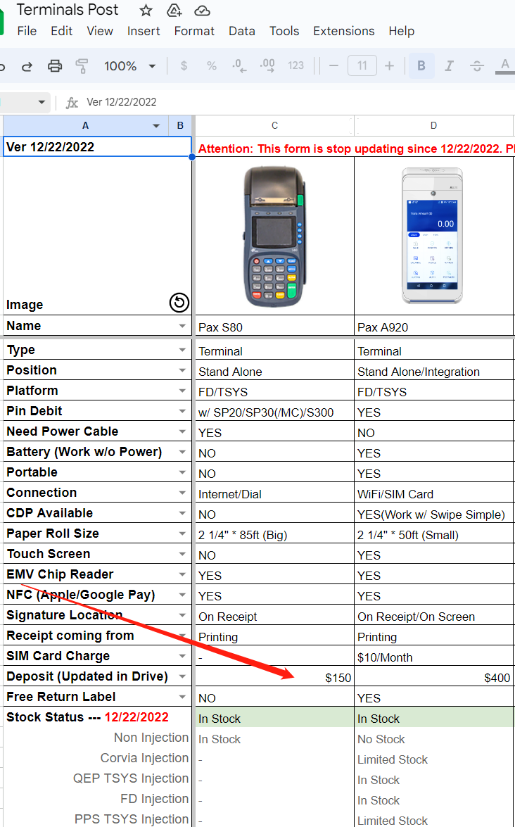

Please search “[**Terminal Post**](https://docs.google.com/spreadsheets/u/0/d/1_0-Htb7Kxz9Nb3K0wbGVWyVC8NwxXsbb6wJpgQcIAnI/edit)” in UP google drive

All terminal info in UP will show up!

**Please Note:**

MC only covers up to a $250 deposit.

If the terminal deposit is $300,

MC Cover $250 and the rest will be paid by the merchant.

If the terminal deposit is $350 and above, MC will not cover

M has to pay the deposit in full! **Account Closure Submission**

Closure Request (Merchant Success) Procedures:

1. For Walk-in Customers

Please confirm the closure reason and advise M to sign a closure form then send

it to [Merchantsuccess@letsgoup.com](mailto:Merchantsuccess@uprocessing.com) for records.

1. For all Normal Non-Affiliate* cases from phone calls or emails etc.

Please confirm the closure reason and contact info. Then, send an email to merchant success. The Merchant Success Agent will take care of the reset.

1. For all Affiliate* Deals

Please send the email to the Affiliate and confirm how to proceed. If the affiliate is confirmed to close, please send out the closure form to the merchant and copy the agent in the email. Please close the ERP and submit a closure request in the backend.

**Affiliates\*** are our 1099 partners and our resellers

All Hebe, Zalak, Yang Li，Vick(xiuying) Chen，Penghui(Affiliate) and other reseller related deals we treat as Affiliate deals.

**Affiliate* Deals Closure Procedures**

1. Attach the closure form in ERP and close OpenERP

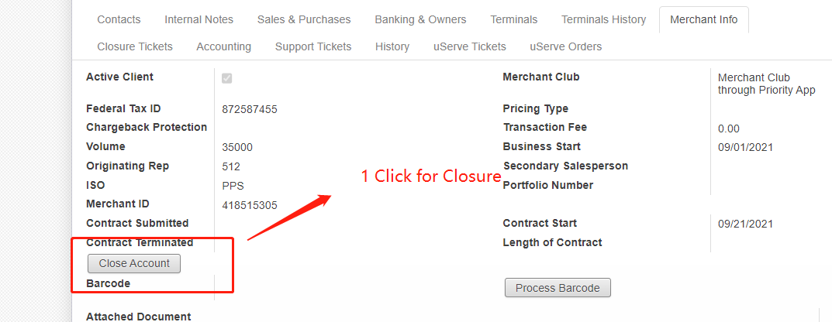

PPS- Open a Closure case in MX connect

QEP- Send a closure request email attached with M signed CF to [support@quantumepay.com](mailto:supportsupport@quantumepay.com) and cc [cs@uprocessing.com](mailto:cs@uprocessing.com)

Corvia- Open a Closure Ticket in Corvia Portal and attach a M signed CF

Defyne(Cardconnect)- Submitted a ticket in Copilot under risk/collection- Account closure.

SigPay- a closure request email attached with M signed CF to [support@signaturepayments.com](mailto:support@signaturepayments.com) and CC rm@uprocessing.com

**To New OP members:**

As operation members, once we receive the merchant's phone call regarding the closing account, we are the first **defense to prevent the account from closing**. At this point, I believe that you guys always try your best to explain to the merchants all of their concerns.

Please remember to **verify the caller's identification** to check if it is the real registered owner under the account.

If it is not the actual owner, you can explain to the caller that we only can talk to the real owner regarding any issue related to the closure.

After you confirm it is the real owner of the account, **please get the actual closure reason.**

The closure reason is significant to the attrition report. **Please make sure you log the closure reason in OpenERP**

If it is the first time the merchant is calling to close the account, **please check the original application to verify the ETF condition** for the specific account and explain to the merchant.

Usually, the account has a 30 days notification with a regular volume process.

### 

### 

### 

### 

### 

### 

### 

### 

### **Account Reinstatement**

### **1 From OpenERP side**

### Find the merchant in “Customers” and Click into the Merchant’s home page.

* Click “Edit“

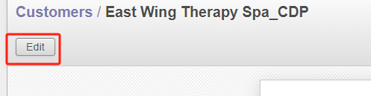

* Check "Active Client”
* Restore”Merchant Club”Status
* Delete “Contract Terminated” Date

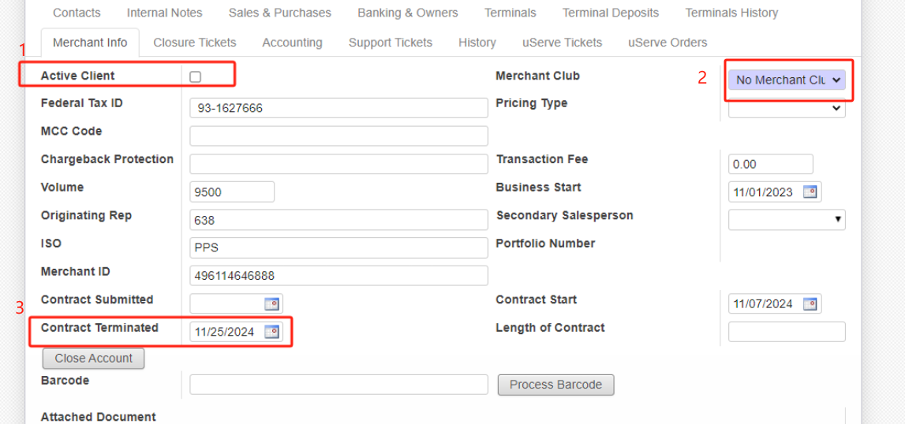

**2. Backend Side.**

Please submit a reinstatement request to backend support team

(PPS, QEP. CORVIA,CARDCONNECT, SIGNATUREPAY)

For BIN accounts, please reach out to the UW team ([uw@letsgoup.com](mailto:uw@letsgoup.com)) to review, and then follow UW team’s instructions.

For any TSYS backends, new var is needed for the reinstated MID. FD backends needs new DVIDs

### 

### **Change Request Issues/Tickets**

**Update DDA**

**DDA change checklist:**

**0. Ask the reason why merchants need to update the DDA**

**\*If a merchant just changed a bank account, move to step 1**

**\*If a merchant just changes a bank account due to a current account frozen or closed. Please advise merchants to implement a 100% funding hold and move to step 1**

**\*If a merchant changed Tax ID need to update the business account. Please refer to renew procedures**

**Step1.**Get a signed DDA change form with an imprinted voided check or a valid bank letter (bank header, DBA, routing and account number, banker’s signature) or a copy of **full pages** of monthly bank statement, Each bankend has different CRFs. Please use the correct version.

**Step2.** Attach all received New DDA Docs to OpenERP and change the Bank info in ERP

**Step3.** Submit the DDA change request to backend via ticketing System or Email(QEP)

**Step4.** Then, update DDA info in ERP and leave a note.

**Bank letter should include:**

* Legal name
* Business address
* Routing number
* Account number
* Banker signature

Bank letter must be on bank letterhead with current date not older than 2 weeks and include bank rep's Name, Signature and Contact info including phone number. Body of letter must include Merchants DBA/Legal name, Routing And Account numbers.

Following is the bank letter samples

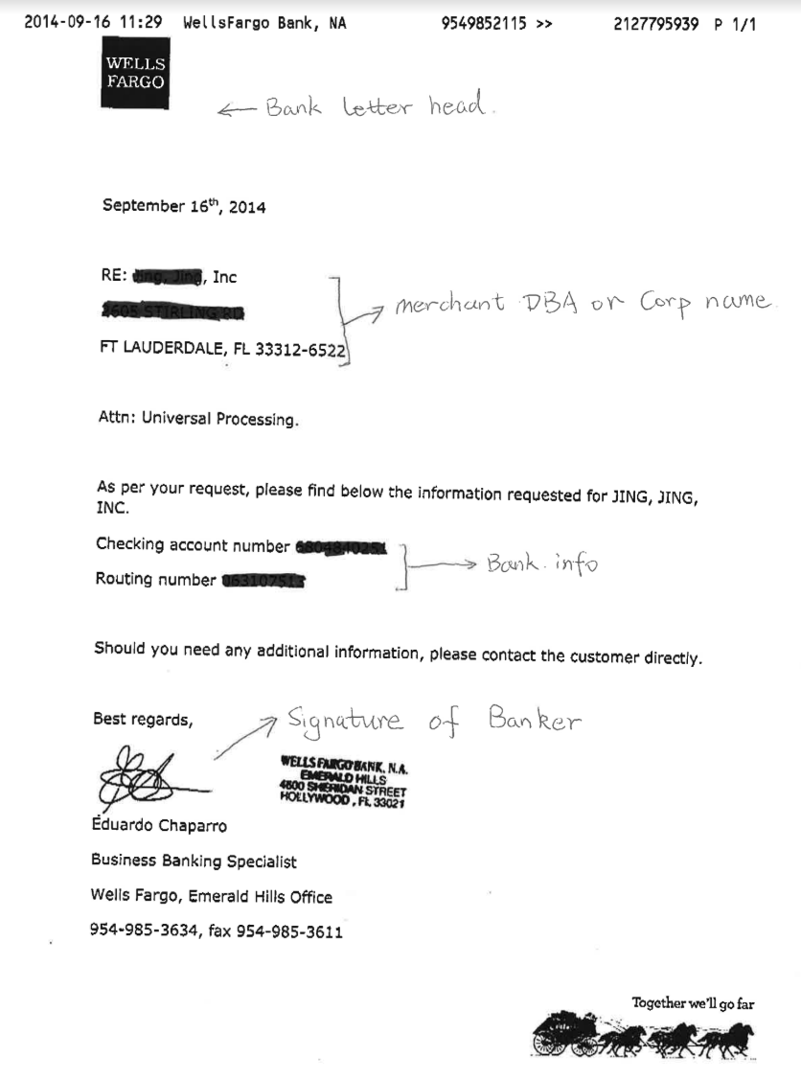

**Imprinted void check:**

A check including business name/corporate name and business address, check number

>#100(BOA:>1000)

**Special Cases:**

* For New Chase bank Account, Merchant can purchase three voided checks with DBA name and business address imprinted
* For a new BoA account, please advise M to provide the account summary page in case the merchant doesn’t have any of the check nor bank letter.
* PPS/BIN accepts the full bank statement with a filled checking account number for DDA change.

**Pricing Change.**

1. M complain the fee is too high / Merchant wanted to check the statement details

**Procedures:**

Please generally **review the account setting and statement** to see if there is any mistake.

* If yes, please contact the backend or manager for a solution. If nothing is wrong, get the merchant's contact information and send an email to the agent.
* If the Agent has left the company, please send it to the Sales Team manager.
* If both Agent and manager leave the company, please escalate to your OP manager to review the price.

1. Agents need to increase/ lower the price.

Increase Pricing: Merchant needs to add a $10 POS Software fee/SIM card fee.

**Procedures:**

Advise M to sign Change Request form with new pricing.(Cardconnect,SigPay using new App pricing page)

Lower the Pricing: Agents or Merchants requested to lower the rate.

**Procedures:**

Submit the pricing change request for the agent directly and kindly inform the merchant.

1. Agent requested to **Change between CDP and Traditional programs within the same Platform.**

**Case:** Merchant disliked the CDP or, M wanted to switch to CDP to save money.

Procedures:

For **Priority Payment System(PPS)**: Alway unpaid renew(Get a New MID).

For **Quantum Epay(QEP)**: Submitted a Program Change Form* to change the price and change the terminal setting after the request was approved (Can be done in the same month).

For **Corvia**：(Get a New MID). Please sign a new Pricing Change Form and open a pricing change ticket in the Corvia portal. Please mention to get a NEW MID!

For **Cardconnect**：Submitt a App pricing page*, the new price will be effective on the1st of the following month. (Can not be changed in the same month). Then Schedule a time with the CS team to update the terminal file.

Different platforms are treated as renew.

1. **CDP Fee Discrepancy**

**Case**:Merchant complained they received less money than they expected.

Procedures:

*Keep in mind the formula. $100 * 3.95%(Terminal) =$103.95 *3.8%(Backend)

Using[**CDP Calculator**](https://docs.google.com/spreadsheets/u/0/d/1Ze2pEsqZmlFx5BmwKBVQJIBb2xPkPZXc_bOBwridUuQ/edit) to check the terminal and back end rates.

Tips can not be added to the SVC on most terminals, please consider backend% of the tip amount as merchant’s business expense, M have to pay for the Tip’s part.

If the difference is still greater than $1 after take out the Tip’s part, please check the terminal rate setting and **review the account setting and statement**

**Address Change**

Address change is a huge category, including address change, email change, mailing address change, legal address change and phone number change.

For any of the information to be changed above, we have to advise M to sign a change request form, and submit to the backend accordingly.

For any physical address change. M have to provide a Government issued license, voided check, or Utility bill to approve the change.

**TIN validation, Backup Withholding(BUW)**

**TIN**(Taxpayer Identification Numbers) **invalid** is not only limited in the EIN number mismatch, sometimes the legal address or Business types mismatch can also lead to TIN invalid.

Starting from the fourth month of the TIN invalid. The IRS will charge merchants a Non-refundable $49 per monthly TIN Inv Fee.

Procedures for TIN validation.

1. Get Valid tax document (RS letter[SS4] ,W9, Ior recent tax return ﬁle[1120S])
2. Make sure the business type, TFN and TIN (maybe SSN for sole prop)
3. Submit requests to the backend for validation.

**Backup Withholding(BUW)**

Case: Merchants complain that they are missing funds everyday, after calculation, they are missing 24% of the daily volume. It is because the merchant was withheld 24% by the IRS due to TIN invalid(more than two years), even though we rerun the TIN validation, it will not work, because the money is withheld by the IRS.

Procedures:

1. Let merchant or their accountant contact IRS 1-800-829-4933 between 7Am-10PM to get the 147 C Form (SS-4 also works)
2. Once merchant received the 147 C/SS-4, need to fax it to IRS different department for them to stop the BUW Fax #402-934-4492, or FD can uploaded through Business Track by getting the case# from the IRS.
3. The turnaround time is said to be 7 business days but once the information is uploaded, it may take 3-5 business days for the IRS to stop taking money.
4. Request the backend to rerun the TIN validation.

Note: Funds that have been captured are given back via tax filing during tax season; If merchants want it to be expedited they need to reach out to the IRS if possible.

**Change EIN, Ownership, Please refer to the Renew Section!**

**Deal submission in OpenERP**

**1. Application and General Page**

To begin entering a merchant application, click on the Application tab located in 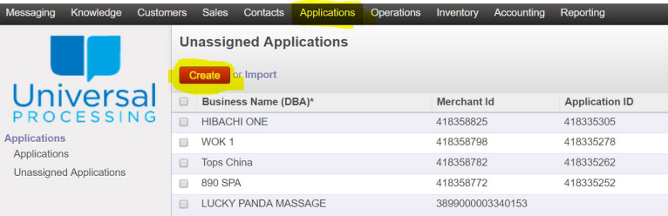OpenERP . Next, click on the Create.

The ﬁrst page(General) of the merchant application will appear.

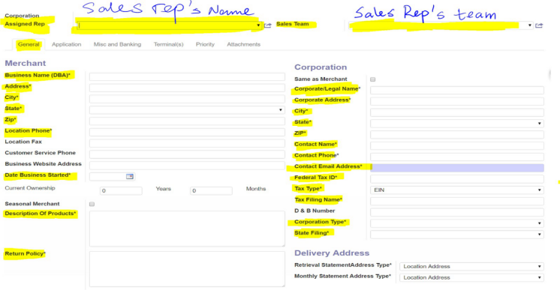

**Part 1. General Tab:** All the highlighted parts which have a star sign must be entered.

**Merchant:**

**Corporation Assigned Rep:** Sales representative’s name.

**Sales Team:** The team of the sales representative.

**Business Name (DBA):** The signage name of the business.

**Date Business Started:** The business opened date. It can’t be later than the day before the entry date.

**Description of Products:** The service the merchant provides. Such as food, spa, nail salon, ect.

**Return Policy:** No return, no refund. Some merchants will have speciﬁc return policies.

**Corporation:**

**Corporation/Legal Name:** The legal name when the merchant uses to do all the legal documents, such as tax reports.

**Address:** It can be the same as the location address. Contact Name/phone/email: Owner’s information Tax Type: EIN & SSN

Tax Filing Name: It should be same as the Corporation/Legal Name

**Corporation Type:** It is usually identiﬁed in the Tax report.

Inc.: S Corporation LLC: LLC or LLP

Owner’s name: Sole Proprietor

If the merchant uses SSN as the Federal Tax ID of the business, the legal name should be the owner’s name.

The legal address can be ﬁlled as the owner’s home address.

In this situation, the corporation type is the sole proprietor. The ownership percentage should be 100%.

**Owner:**

Go down the page and ﬁnd the Owner part.

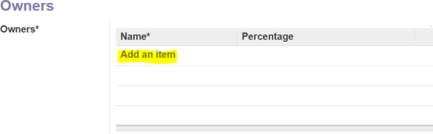

Click **Add an item**.

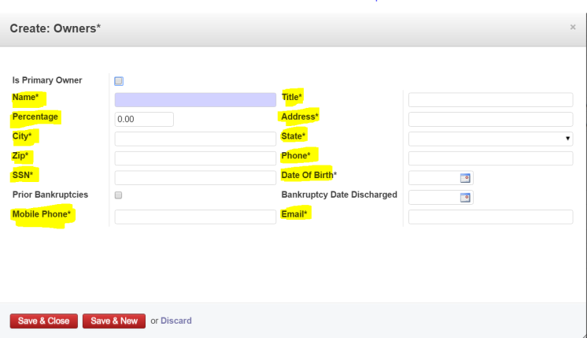

All the highlighted parts with the star sign must be entered.

**(1)Percentage:**

* It should be greater than 50% if the business has only the owner registered. We input 51% usually.
* If the business has more than one owner, you can add an item to input the 2nd owner’s info.
* If the business uses the owner's SSN as Federal Tax ID, the ownership percentage should be 100%.

**(2)Date of Birth:**

If the owner doesn’t provide the date of birth, we must make up a date in order to submit. Please remember to delete in the MX system.

After ﬁnishing the owner part, please click **Save & Close**.

**Part 2. Application:**

Please click the **Application Tab**.

All the parts which **have star signs** must be entered.

**Transaction Type:**

**(1)Business Type:**

Choose Restaurant/Retail. All the business types except the restaurant we choose retail.

**(2)Card Present Swiped & Card Present Not Swiped percentage:**

Based on the owner’s situation. Usually we put 90% & 10%.

**(3)Internet Ecommerce percentage:**

If the application needs to apply online payment gateway Authorize.net, we should put the percentage in here. If this is an account only for online gateway, input 100% in here.

**Notes Sections:**

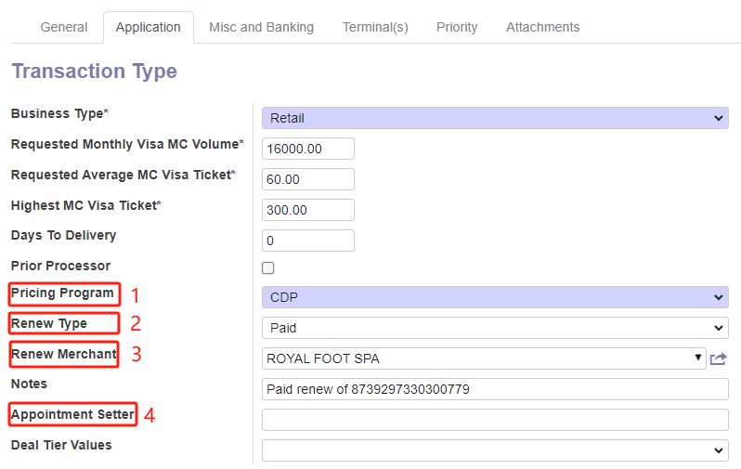

* **Section1.** Please choose CDP/Regular deal type
* **Section2.** There are four types of renewal types.If any apply,please choose co-related types
* **Section3.** Please search/type the previous merchant ID in the field and the “Notes” section will be populated. Please **DO NOT** write anything in “Notes” yourself.
* **Section4.** AS Deal. Please input AS Name accordingly, if any.

–Save and move to Misc and Banking

**Part 3, Misc and Banking**

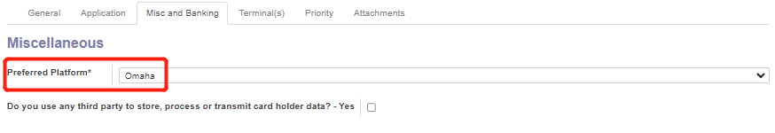

Preferred Platform always choose Omaha

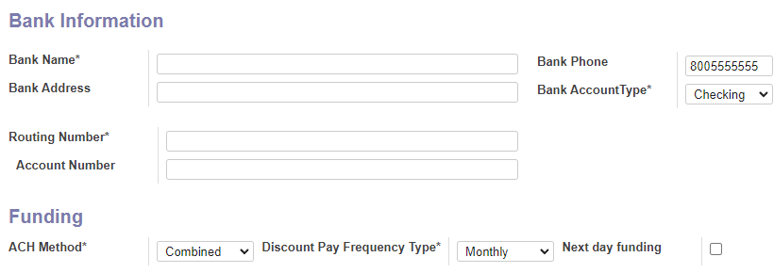

Then Fill in the bank account info per banking info or the application and double check.

**Part 4, Priority**

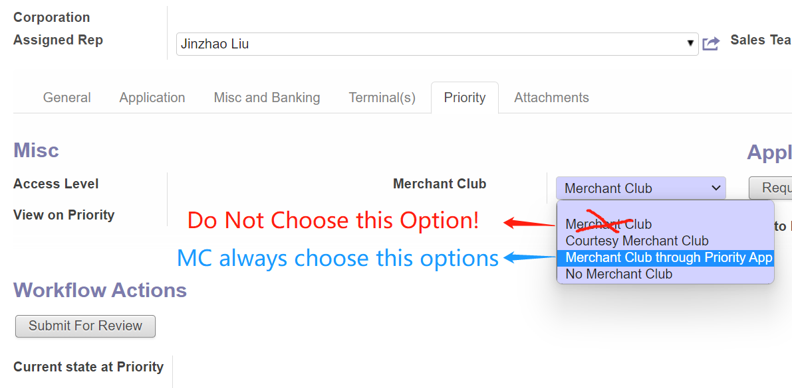

1. Merchant Club: Regular MC. **UP charges** $23.88/month for each account individually.
2. Merchant Club Through PPS: The MC charge of $23.88 is included in the PPS/QEP monthly statement. Or for all the CDP accounts, we choose this option in OPENERP. The CDP account doesn’t get charged for MC but gets MC services.
3. Courtesy Merchant Club: No fee charge but merchant has same access with MC
4. No MC: Merchant doesn’t want to join MC.
5. The ﬁrst terminal merchant or the sales representative needs to pay a terminal deposit.

After choosing the Merchant Club type. We need to go to Attachments

**Part 5, Attachments**

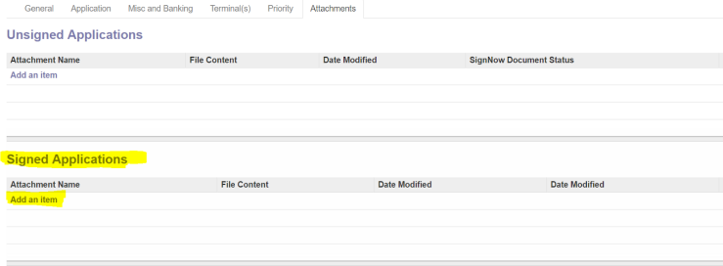

We need to attach the original application package in Signed Applications. Add an item.

All the work in OpenERP has been done, then we go back to the Priority tab to Submit to Review.Then Submit to Priority. It will ask you to choose the sales representative’s name again.

❏ For Non PPS applications, you do not need to click Submit to Priority. Once the application is approved in QEP, we can override the approval in Openerp.

**6.Duplicate Application Situation**

OpenERP has an application duplicate ﬁlter in order to check potential deal conﬂict.

Once the application current is submitted which has the same DBA, location address, and same owner with any one existing application in the system, duplicate notiﬁcation will come out when you try to submit to Priority.

1. **It will show the OpenERP Warning prompt. Please click OK in the prompt then click the Override Duplicate.**

If you can click Submit For Review and Submit For Priority regularly, congratulations! Your submission in OpenERP is successful!

But sometimes life is not easy. The duplicate ﬁlter can’t be overridden after above simple progress.

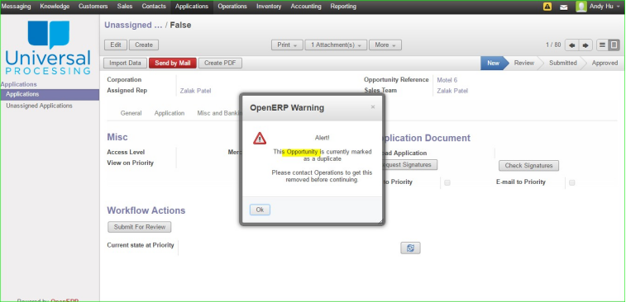

OpenERP still shows this warning.

1. **Please Click the Opportunity Reference Link.**

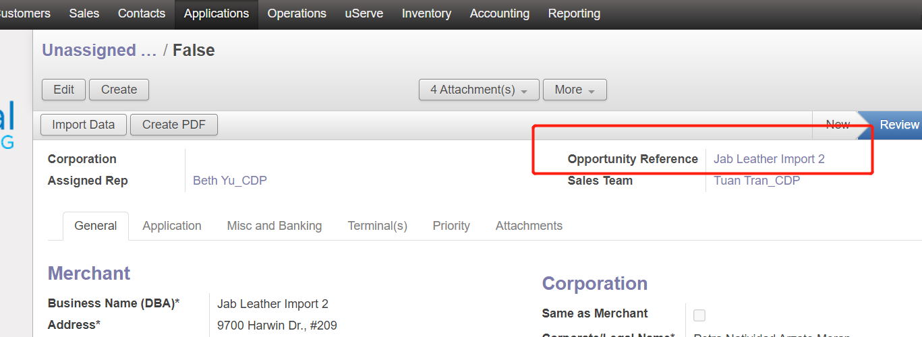

Click the Edit button and paste the DBA name and save. Then click the “Override Duplicate” at the bottom.

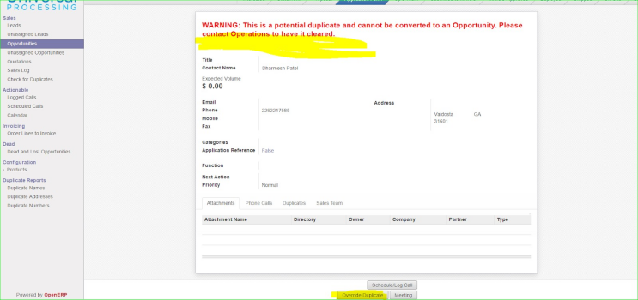

After that please save it then click “Override Duplicate” bottom again.

Then go back to the application page to try to submit again.

It should be ﬁne.

1. **Override MIDs After Deal is approved.**

After we finish the OpenERP, please submit the deal to the backend and follow up with agents. **Once the new MID is approved.** All PPS accounts’ MID should populate to OpenERP, for Non PPS MIDs, we should copy from back end and Override to OpenERP.

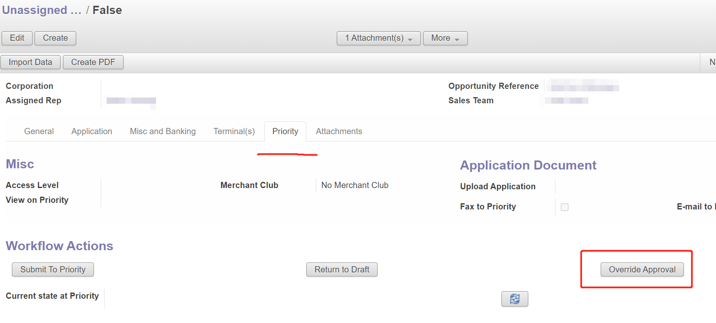

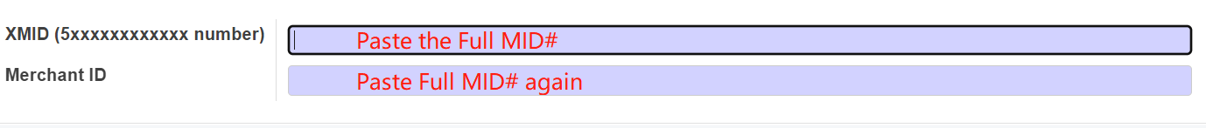

**Renewal, Paid, Unpaid.**

1. If the owner changes or the legal name is changed, a renewed application is required.
2. Paid renew, owner, legal name, location address, change at least 2 item

Unpaid renew, only 1 item is changed

1. Usually we apply same pricing for renew account
2. After submit the renew deal, please add renew account info to Renew google sheet, so that we can keep tracking
3. If the merchant wants to change the program( regular discount plan or CDP plan), the unpaid renewal application is required. If the transfer happens within 5 months since the new application is submitted, it needs to be marked as 5.X.

| Owner | Address | Tax ID Info | Deal Category |
| --- | --- | --- | --- |
| **Diﬀerent** | **Same** | **Diﬀerent** | **Paid Renew(New)** |
| **Same** | **Diﬀerent** | **Diﬀerent** | **Paid Renew(New)** |
| Diﬀerent | Same | Same | Unpaid Renew |
| Same | Same | Diﬀerent | Unpaid Renew |
| Same | Diﬀerent | Same | Unpaid Renew |

*Paid or Unpaid Renew Form

**Pre-Underwriting Process.**

Please escalate if the check or ID looks fake.

Please escalate if the pricing, fees look abnormal.

Please escalate if the Bank account info list on application form is incorrect.

**Missing TSYS Association IDs.(PPS TSYS Only)**

When we submit deals for new Agent in PPS Tsys, the first submission always have following error message shows up.

Please Call PPS RM at 844 225 2674 or send a email to [rmteam@pps.io](mailto:rmteam@pps.io) with Application name and Agent information. Tsys RM team will help us.

|  | |
| --- | --- |
|  | |

**Deal Submission Checklist**

1. **General Info, Tax info. Typically the Ste # and Tax ID.**
2. **Owner SSN**
3. **Bank info*, Please ALWAYS double check the routing # and account number from three references**

**1) from the check or bank letter,**

**2) from the Application**

**3) our systems.**

**Alway make sure all three references are the same.**

1. **Pricing**

**1) IC+ or Flat. IC+ will select Separate Due and Assessment fees Flat rate will alway select included.**

**2) Daily or Monthly Discount**

1. **The Notes. Renew notes and renew list. AS notes and Special Deployment notes**

**Transaction Related Issue.**

1. **Add tip (or CC#Related.Refund, Rerun sales, Rekey etc.)**

Merchants usually forget to add the tip before closing the batch. To Make it up. We have to get the full card number and expiry date for M to re-run tip transaction

**Procedures:**

1. Check if Merchant has closed the batch or not, if M has not, M needs to adjust on terminal. If yes, move to **step 2**
2. Making sure if the sale is still within 1 week and advising M the risk of chargebacks.
3. Get the card info (sale date, Last 4 of cc# and the $ Amount)
4. Get the full card numbers and Expiration date.

We have two ways to get card numbers shows as below

**1).Call backend Agents**

Please prepare info prior to connecting with a backend agent, we have to pass the verification to get further information.

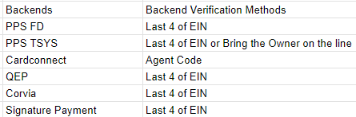

**2). Ask for Senior Supports/ Managers.**

We can acquire full card info directly from the M report. But only limited to QEP Corvia and BIN. QEP cannot get Same day info.

Please provide MID last 4 of CC, dollar amount, date to the Gtalk group.

**\*\*\*5.** The Most Important Part! ID Verification!

Please verify the the owner ID by verifying last 4 of the owner SSN# or the Last 4 of EIN # before releasing the card info over the phone.

**More than 20 CC#s add tips or Rekey Request**

PPS(More Than 25 cc#s)- Need a PPS rekey form and PPS for merchants.Cost will be $50 for 2 hour base, $25 per extra hour.

How to do:

1. Get a detailed report form backend and filter the rekey list with tip Amount.
2. Advise M to sign the PPS rekey form.
3. Open a case in MXconnect under [transaction rekey] and attach the documents above.
4. Follow up with the PPS CS team and inform M when it’s done.
5. Corvia, QEP., more than 20 cc# Please Sign UP rekey form **(Download from sales folder) and Additional charges** may apply, $25 per hour.

Notes:

1. Rerun tip sale by retrieving cc info from backend is not adding the amount to original sale, therefore, merchants have a risk to get chargebacks or complaints.Please kindly inform new merchant regarding this matter.

2. Different terminals may have different steps for key-in sales. Please refer to the terminal user guide.

**Rekey**: After we received a Rekey request.

1 Get a var or DVID and build a pax s80 file.

2. Get the cc auth sheet

3. Force the transactions per request.

4. Review the Amount and Auth Code

5.Close the batch and inform the backend risk team

**Reseller/1099K agent no sales team related**.

1. Ownership verification, if passed, released the cards
2. If it can not pass. Please reach out to RM or call us back later.

**2. Authorization Hold**

**Example:**

Merchants complain that they charge the cardholder $100 but the cardholder banking app shows $120 pending.

**Procedures:**

Please advise M that Authorization Hold usually happens in service industries(Restaurant, Massage etc.)

Once the cards that are almost out of balance, or the cards are certain debit cards, auth hold will happen. It is a way that the card issuer bank helps the merchant reserve 20% of the sale for tip adjustment. The extra credit will return to the cardholder once the transaction is posted to the statement without any adjustment.

**3. Double Charges（Muti-Charges)**

**Example:**

Merchant charged a card one time for $25 but on the cardholder banking app shows $25

two or more times

**Procedures:**

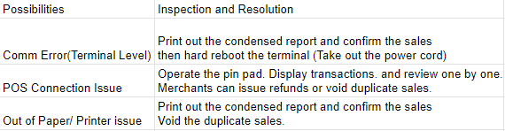

*Call the backend to check is alway the backup plan for the sales confirmation.

**4. Chargeback and Retrieval**

**Chargeback:**

A chargeback is a transaction disputed by the cardholder or issuer. There are many reasons for chargebacks, but the most common are returned merchandise, terminated service, disputes, chip liability shift, errors or fraud. Chargebacks are a costly part of accepting credit cards, which cannot be 100% avoided. Amount in dispute will be deducted from M’s account immediately, and refunded to M’s account if M wins the case.

**Retrieval:**

A retrieval request occurs when the card issuer or cardholder asks the merchant for a copy of the actual ticket of a transaction. A retrieval request is not necessarily changed to a chargeback. Usually, no money will be taken out from M’s account. Except for high ticket retrieval, PPS will usually hold that amount until the case is over.

Procedures of CB or Retrieval Response:

When a merchant receives a chargeback/retrieval notiﬁcation letter, please fax required documents (signed receipt of that transaction and invoice if applicable) to the fax number provided on the letter, with case number listed. Or merchants could contact us and send required documents to OPs, we will fax or upload a chargeback/retrieval response.

For all FD accounts, please fax to 402-933-1525

For uP BIN, PPS Tsys and QEP accounts, please upload through the portal

<https://merlinkresponse.com/>

For Corvia Accounts, please upload through the portal with the chargeback notification letter. It is mandatory, our CS team has to ask merchants to provide either an email or paper-based version.

<https://elevateqs.com/ChargebackUploader/>

*( Corvia link is CB only, Retrieval please get the letter and fax to the number on file)

### **PIN DEBIT CHARGEBACK**

### Pin Debit transactions also have chargebacks, but usually handled by the Acquiring banks

Procedures:

For **PPS** merchants,

Once the merchant gets PIN DEBIT chargeback, please advise the merchant to provide the PIN DEBIT receipt of the case and we can email to chargebacks@pps.io to help M to respond to the case. for PPS, the one who is in charge of PIN DEBIT Chargeback is Yolanda Harris <yolanda.harris@pps.io>, the fax# is 402-916-8576

For **QEP**,**Corvia and SigPay** merchants,

Once the merchant gets PIN DEBIT chargeback, please advise the merchant to provide the PIN DEBIT receipt of the case and we can email to their cs support emails and follow up.

For **Cardconnect** merchants,

Please check the pin debit chargeback ticket in the CardConnect **Copilot** portal and reply to the ticket.

**Common Types**

**First time chargeback,** the cardholder first time dispute the sales

1 Duplicate processing: need merchants to provide all related sales receipts to prove the cardholder purchased multiple times.

2 Services related: need merchant to provide or explained the full services items

3 Fraud

4 EMV liability shift

**Pre-Arbitration,** the cardholder continue to challenge or the card issuers rule the case

Please advise the consequence if they still want to challenge because a huge additional fee will be applied after registering the arbitration case.

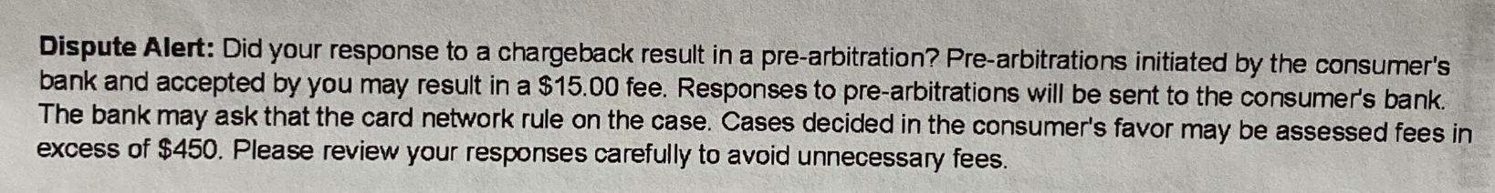

*PPS FD Sample

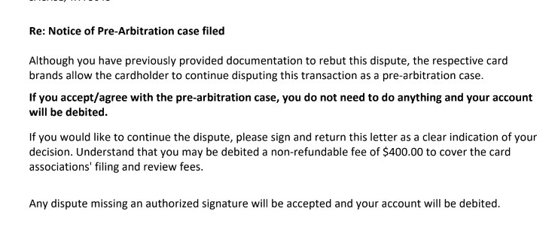

**\***Corvia Sample

There are several diﬀerent types of chargebacks:

* Criminal Fraud – When a stolen card is used to make a purchase.
* Merchant Error – When the merchant makes a clerical error such as duplicate or incorrect billing amount.
* Service Error – When a company has poor return policy procedures, misrepresentation of product or services not fully delivered to client’s satisfaction.
* Friendly Fraud – When a customer has buyer’s remorse and changes their mind or does not recognize the charge on their billing statement due to descriptor or diﬀerence in currency.
* Liability Shift- Terminal file out of compliance/ Hand-key transactions

For a merchant, chargebacks are the dreaded headache, but you can help reduce chargebacks and alleviate concerns by following these **few steps:**

1. Chip or Tap the Card, reduce key in sales
2. For Key in sales, use address verification system AVS to check the card info, if zip, cvv does not match, M has to be aware of the potential fraud.
3. Please refund the wrong charge ASAP. Cardholders can not dispute a sale that has an offset refund transaction.
4. Keep the terminal file up to date.

**PPS Amex and Discover dispute fee**.

Amex and Discover disputes will only be assessed $20 regardless how much you put for chargeback and retrieval. (We were misled by PPS last year. The previous information that "$20 is on top of your pricing" was incorrect).

**Chargeback Amount Is Little More than Receipt Amount:**

The card is an international Card. Please consider the exchange rate into the case

**Risk & Funding(ACH)**

**Risk And Follow up**

Usually the Risk case could be, ACH reject, Transaction exceeding the ceiling limit. Fraudulent activities,and massive chargebacks.

Once the CS team member receives the notification or is assigned a risk case, Please contact the business owner and the sales agent **immediately**. Merchants have to reply to the cs team with the required information.

**Next day funding issue.**

Next day funding provides merchants with funds from credit card transactions within a single business day. The payment processor sets a cutoff time, and any transactions processed prior to that time will be available the next business day, while any that come in after will be available one day later Because that quicker release negates some of the risk mitigation benefits, next day funding services often come with a slight bump in fees, but the result is that merchants can access their money sooner, rather than having it sit in a payment processor’s bank account instead.

**NDF Cut off Time**

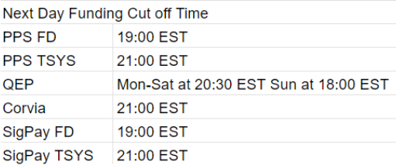

**Copilot (north) 16:00 EST**

**uP BIN TSYS 22:30 EST**



**Omaha funding type. Type 7 vs.Type B**

New boarded FD Omaha merchants who have discrepancy with PinDebit EBT funding is because of the ETC type issue. Merchant usually prefer Type B, please help to submit a case through MXconnect under the case type: 

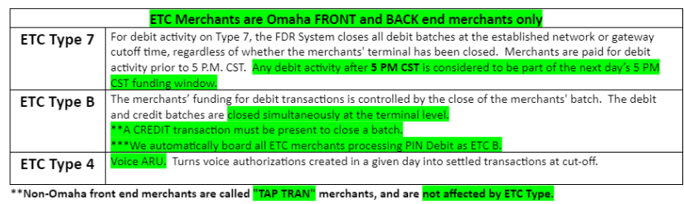

**Add Next Day Funding (NDF)**

All none-massage applications regardless of the platforms should qualify the next day funding. Sometimes the underwriting team did not give next day funding(24hrs funding) therefore, we need to send the NDF request to the backends.

Low risk accounts: restaurant, nails spa etc. submitted the request directly to the backend.

High risk accounts: Furniture, Granite, wholesales etc. the high avg ticket account. They could qualify if they have a high enough deposit in the bank account, at the same time the key-in percentage is higher than 80%. We can submit their most recent 3 months bank statements to the UW team for review.

Massage accounts: except Corvia deal, all other platforms can apply NDF once application was approved.

**Funding Missing/Delay**

Case: Merchant complained that they process cards everyday but they did not get the deposit.

Procedures

1. Check if the Merchant closes the batch everyday and get the most recent batch date.
2. If merchant on NDF, but close the batch after the last cut off time, please advise M to wait to tomorrow
3. if the merchant is on NDF but no deposit received from 2 days ago please call or research in the backend for the reasons. Could be, ACH reject, Chargebacks, Risk hold Etc. and advise M to provide the docs that bankend requested.
4. If the merchant is not on next day funding. Please calculate the estimate funding time and advise M
5. The National Holidays settlement network doesn't work, so there will be additional delays on funding.
6. Check if the DDA info is correct. (refer to DDA change request)

**Check Uncertain Charge.**

Case: Merchant complained that we charge them a certain amount.

Procedures:

1. If the charge is at the beginning of the month, please consider the fee as monthly fee first, go check the statement and confirm.
2. For a fee that is separate from the statement but from the backend at the beginning of the month. Please consider it as a **chargeback fee** first. Please call the backend and confirm.
3. If the charge is not at the beginning of the month, please consider the chargeback dispute first. Go check the chargeback history and confirm.
4. If several charges applied after a huge sale was settled. It could be Maximum downside exposure(MDE). Please call the backend for details.

**ACH Reject**

ACH Reject(ACH REJ) is the acquiring bank that can not deposit or withdraw funds from merchants.

There are certain reject codes that do and do not incur the ACH reject fee of $30.

Reject codes that do incur the fee:

R01 - non sufficient funds

R02- DDA closed

R29 - corporate advised not authorized

R16 - DDA frozen

R10 - customer advises not authorized

Reject codes that do NOT incur the fee:

R03 - No DDA/unable to locate

R04 - invalid DDA

R05 - no prenotification on file

**Common Reject Types and Procedures:**

R01 Insuﬃcient funds

Advised M to make sure there are enough money in the bank account

R02 Bank account closed

Need to get the new bank account information, refer to updated DDA

R03 No bank account

DDA info in our system is not correct, maybe due to typo, need to check with original document or merchant.

R04 Invalid bank account number

Same as R03, wrong DDA info, need to check

R08 Payment stopped

Need bank letter stating “bank has removed stop payment, ‘Backend’ are allowed to debit/credit money on merchant's bank account”, with banker’s signature

R16 Account frozen

Account Frozen/Entry Returned per OFAC Instruction: Access to the account has been restricted due to legal action or specific action undertaken by the RDFI, or the OFAC (The Office of Foreign Assets Control of the US Department of the Treasury) has instructed the Gateway or RDFI to return the Entry.

**Check Released Funds**

After ACH reject or Risk hold were removed.if merchant ask

1. Check the most recent deposit portal
2. Check the notes and email records
3. Call the backend for detail info

**Increase Risk parameter/ High ticket amount.**

1. Acknowledge M they should be responsible for the CB risk
2. Provide the 3 monthly Bank statements to show Merchant’s ability.
3. Submit the request to backend by ticket or Email

**Fundamentals of Fraud Risk Control**

**Payment fraud** is a type of financial fraud that occurs when someone intentionally uses false or stolen payment information to make a purchase. For example, fraudulent actors might use stolen credit card information, create fake checks, or make unauthorized electronic fund transfers.

Retail businesses are particularly vulnerable to payment fraud since they deal with a large volume of transactions and may not have the resources to thoroughly vet each payment method. Payment fraud can result in significant financial losses for businesses, damage to their reputation, and legal liabilities.

**Credit card fraud** is the unauthorized use of a credit card to make purchases or obtain cash. For instance, this fraud can involve the use of stolen credit card information or the creation of counterfeit credit cards. In credit card fraud, the fraudster can use the stolen credit card to make purchases online or in-person, or they may use the card to withdraw cash from an ATM.

Credit card fraud losses increased to [$4.2 billion in 2020](https://www.waylay.io/articles/understanding-the-threat-of-card-transaction-fraud-and-its-impact-on-the-financial-ecosystem), up from $3.5 billion in 2019. Card-not-present fraud is expected to increase from 57% in 2019 to 74% by 2024.

**Debit card fraud** is similar to credit card fraud but involves the unauthorized use of a debit card. The fraudulent actor may use a stolen debit card or the card information to make purchases or withdraw cash from an ATM. Debit card fraud can also occur if someone obtains access to the PIN associated with the card.

**Bank fraud** refers to any type of fraud that involves a bank or financial institution. This can include fraudulent loans, account takeover fraud, and identity theft. Bank fraud can result in significant financial losses for individuals and institutions.

**Mobile payment fraud** is the unauthorized use of mobile payment services, such as Apple Pay or Google Wallet, to make purchases or transfer funds. This can occur if someone gains access to the victim’s mobile device or payment information. Mobile payment fraud can also occur if a fraudulent actor creates a fake mobile payment account using someone else’s information.

**What defines Fraudulent Accounts?**

Fraudulent accounts are more commonly found in online payment businesses. They often claim to be 100% online and do not require a physical card terminal.

Another common scenario is when fraudsters target an abandoned store that has been inactive for a long time. They use excuses such as account updates or a change of ownership, along with fake IDs and tax information, to set up a credit card processing account, enabling them to cash out illegally.

**How to prevent fraud?**

1. **Strictly review merchant information.**

Ensure that merchants provide authentic and valid business licenses, tax information, and identification documents, and verify their historical transaction records.

1. **Be cautious of merchants conducting fully online transactions.**

For merchants claiming to be 100% online and not requiring a physical card terminal, conduct additional reviews, such as verifying their website, business model, and transaction history.

1. **Pay attention to account change requests.**

Carefully verify the authenticity of supporting documents for requests to change ownership or update account information, especially identification and tax information.

Monitor abnormal transaction behaviors. Use a risk control system(CRM, Notes) to detect large transactions within a short period, repeated transactions, or abnormal refunds, especially when transaction amounts significantly exceed industry standards.

1. **Conduct regular merchant account reviews**

Periodically review merchants’ transaction history to ensure their business model remains consistent with the initial application, preventing misuse for illegal cash-out schemes.

**What to Do if There Is a Fraudulent Account:**

1. Proactively contact the Risk Department to place the account on hold, and claw back the funds as soon as possible.
2. Proactively contact the Accounting Department to collect the terminal recoup fee.
3. Don’t let the scammer know they’ve been exposed—keep them calm

**High-Risk Merchants**

The MCC’s listed in the table below are acceptable businesses, however considered to be High-Risk due to increased exposure. As a result, they require additional underwriting analysis and will not always be considered for approval.

For further guidance, please consult the Specific Merchant Procedures, recognizing the unique require

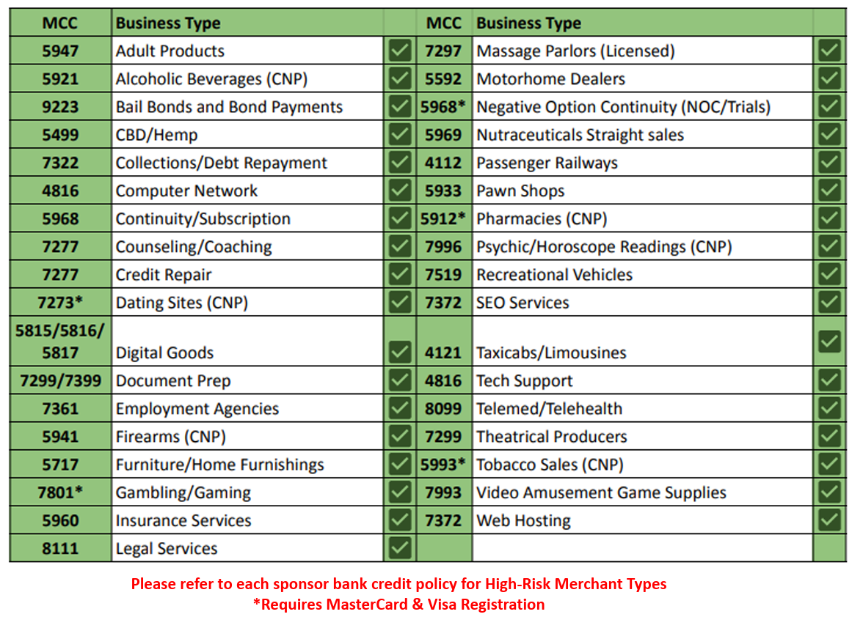

**How to Prevent Being Scammed**

**KYC (Know Your Customer)**

KYC is a process used by financial institutions and payment companies to verify customer identities, assess risks, and prevent fraud.

Before we submit our deals to underwriting, we can do the following steps as pre-underwriting steps to prevent fraud from happening.

**1 KYC on the signor**

Google the signer's name with the city and zip code to look for any negative reputational concerns.

**2. Verify the business**

Internet searches following

* Legal DBA Address
* DBA
* phone number
* Email address

Social Media Research (Facebook, Instagram, etc.)

**Site Inspection**

All Merchant Processing Agreements have the site inspection sections. If you’ve never been to the business location address, please DO NOT sign the inspection section.

Site inspection is an on-site audit or evaluation of the environment where payment processing equipment is installed and operated. This inspection is designed to verify that both the physical and logical security measures are in place and that the site complies with applicable industry standards and regulatory requirements.

**Purpose:**

* **Security Assurance:** Confirm that physical access to critical systems is controlled and that the environment is secure against tampering, fraud, or unauthorized access.
* **Compliance Verification:** Ensure adherence to industry standards such as the Payment Card Industry Data Security Standard (PCI DSS) and any additional requirements set forth by card brands (e.g., Visa, MasterCard).
* **Risk Management:** Identify and mitigate risks related to data breaches, fraud, or operational failures in the card payment process.
* **Quality and Performance:** Evaluate the installation, maintenance, and performance of payment devices and supporting infrastructure.

### 

### **Site Inspection Standards in the Card Payment Industry**

* **PCI DSS Compliance:** The Payment Card Industry Data Security Standard (PCI DSS) is a foundational guideline that covers many aspects of security for card payment systems. During a site inspection, auditors check for:
  + **Access Controls:** Policies and systems in place to limit access to payment systems only to authorized personnel.
  + **Physical Security Controls:** Measures that protect cardholder data from unauthorized physical access (e.g., locked server rooms,).
  + **Network and Data Security:** Proper segmentation of networks, encryption of sensitive data, and secure key management practices.
  + **Environmental Controls:** Adequate safeguards to protect equipment from environmental risks (fire, water damage, etc.).
* **Manufacturer and Vendor Standards:**For devices like POS terminals or ATMs, additional standards such as PCI PTS (PIN Transaction Security) may apply. These guidelines ensure that:
  + **Device Integrity:** The hardware has not been tampered with and is installed according to manufacturer specifications.
  + **Software Security:** The payment applications are secure, up-to-date, and resistant to malware or hacking attempts.
* **Local Regulations and Industry Best Practices:**Depending on the country or region, additional local regulations may dictate specific site inspection protocols. These might include:  
  + **Data Privacy Regulations:** Ensuring compliance with local data protection laws.
  + **Industry Best Practices:** Following recommendations from industry groups or standards organizations (such as ISO/IEC 27001 for information security management).
* **Inspection Process:** A typical site inspection in this industry will involve:  
  + **Pre-inspection Review:** Evaluating existing documentation, security policies, and previous audit reports.
  + **On-site Audit:** Physical walkthroughs, interviews with staff, and hands-on testing of equipment and controls.
  + **Reporting and Follow-up:** Documenting findings, highlighting any non-compliance issues, and recommending corrective actions.

**Please escalate to your managers if you experience any of the following situations:**

* **OpenERP Info Mismatch:** The DBA name and DBA address on ERP should match 100% with the backend CRM portals. Do not assist anyone in changing the DBA information without a merchant-signed change request form. If you encounter any discrepancies, please escalate for advice.
* **ERP Duplicate Warnings:** When submitting deals, if you receive an ERP duplicate warning and all information is identical with a previous deal, please escalate for advice.
* **Signature Verification:** Always compare the physical signature with the merchant’s driver’s license. If the signature does not match, escalate for further guidance.
* **Closure Requests:** If the MID did not process any transactions or the total is less than $500, this case should be flagged. Please escalate for advice.
* **Terminal Deployment Issues:** If a new location has been without terminal deployment for a long period (i.e., 0 terminals at the location) and the deal shows an AS effort, please escalate for advice

**Terminal Issues & Requests**

**Knowledge Tour Guide**

We have a sophisticated Wiki system built in OpenERP. In this section, you can find most of the terminal troubleshooting procedures by simple input the Error message shows on the terminal.

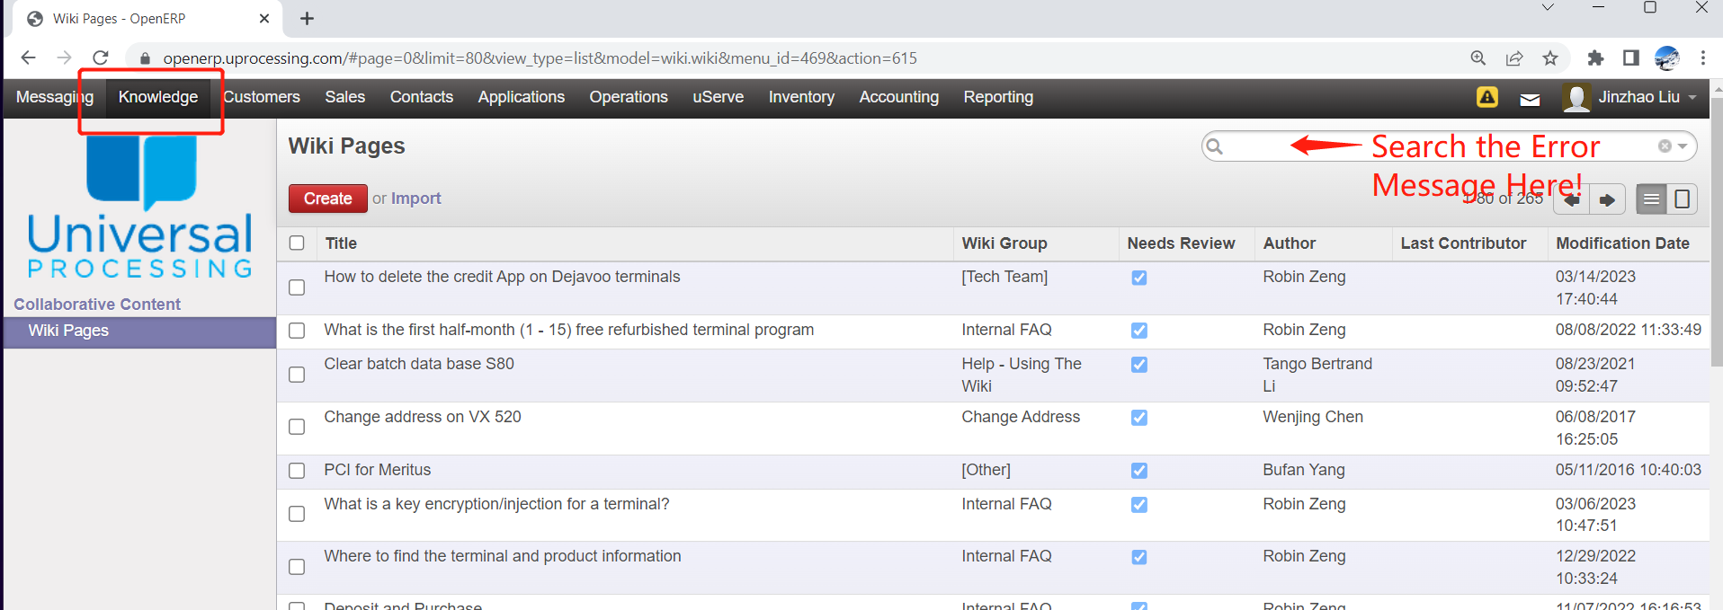

For Example, if a Pax S80 terminal shows “NPM” on the screen, then in the Wiki page, please search the key word “NPM”. Then, you will have the following result.



Please click on the title then the resolution will show up.

We will simply get the solution and reply to our merchants faster!

Most of the Terminal issues can be found on the wiki page. But, new cases alway challenge us without preparation.

For the issue that we can not find on the Wiki page. You still have two ways to resolve the issue.

1. Check with your manager or ask in CS groups. or
2. Call the terminal manufacturers support team for help.

Currently, our tech team can deploy following brands of terminals

PAX, Dejavoo, Valor, Swipesimple and Apriva. These terminals' basic information, inventory and updates can be found on the [Terminal POS](https://docs.google.com/spreadsheets/d/1_0-Htb7Kxz9Nb3K0wbGVWyVC8NwxXsbb6wJpgQcIAnI/edit#gid=0) in our Google Drive.

**Common Issues and Procedures**

**Terminal Basic Troubleshooting Strategies**

1. Error, ask the error message, be specific.

2. Connecting Types, please make sure if merchant is using LAN, Dial, Wifi or 4G

3. Implementing Troubleshooting.

**Hard Reboot** is about to cut off the terminals’ power supplies. It is very useful when a merchant is suffering from Comm Errors but the store internet environment is good. Therefore, please advise M to hard reboot the terminals before implementing advanced troubleshooting.

**LAN Types:**

1. **DHCP,** Dynamic Host Configuration Protocol (DHCP) IP address can be changed Automatically, Usually used for standalone terminals.
2. **Static IP** address is an IP address that doesn't change over time. Use for semi integration pin pads(A35, S300, SP30)

**Ping Test:**

Ping Test is a fast and accurate tool for quality measurements of the Internet connection.

Pax terminals Ping Test:

Menu(Func/ F+1)--Communication– LAN Parameters– Ping

Dejavoo terminal Ping Test:

F1 --> Comm. Status --> Down arrow button twice --> OK (For Ping) --> Google

**Comm Error**

Symptom 1: Pax brand Terminals show “Processing…” all the time.

Resolution: Hard reboot terminal by taking out the power cord.

Symptom 2: Pax S80 shows “Retry”

Resolution: Get to know of the terminal Main Comm Type is on Dial or LAN

**If it is on Dial,**

1. Please extend the connect/ received time out to 900 or more.
2. Disable the Dial tone check.
3. check the the prefix # if the terminal is still not working.

Nothing more we can do after these steps. Please advise M to call the service provider.

**If it is on LAN** Please help merchants troubleshoot LAN connection or call internet providers. Ping Test, reboot the router, reboot LAN switch, replace the Ethernet cables.

Symptom 3: FD accounts terminals PING OK but show comm error during processing.

Resolution: Datawire corrupted, please provision a new datewire and change in file or

ask seniors for help.

Symptom 4: TSYS account show Received Error but PING Test OK

Resolution: Please advise the team to review the file parameters or check with the

backends to see if MCC code was changed.

**Partial approval**

Since 2021, partial approval can not be controlled by terminals anymore. Merchants will complain about this function when they receive the new terminal. Please advise M that this function is determined by the card issuer bank, instead of the terminal anymore, therefore, we are currently out of control of this issue. Dejavoo Terminals can have an obviscion notification.

**Terminal file download.and Guides**

1. Pax, Must connect with LAN or Wifi, Dial or 4G can not download.

**Auto download:** S Serial: Close the openbatch and reboot the terminal

A Serial: Close the open batch, then,No action needed or Tap the Pax Store App.

**Manual(** S- Serial only): Menu- System Setting- App Management- Activate- Online- Cancel 2 times- App Update.

1. Dejavoo File download:

Please wiki keyword Partial or Full

Partial downloads only update a function or a setting.

For any Host setting update for example, MID, datawire change. Has to be the full download.

1. Valor: Enter EPI, check wiki page.

**Key Injection/RKI**

Key Injection refers to injecting encryption keys for a payment processor being used to handle PIN Based Sales, known as Pin Debit, EBT sales that need PIN verification. Therefore, different backends have different Injections. Please make sure merchants get the correct injected terminals if merchants need to process PIN based transactions.

Pin Debit and EBT sales can **only** be processed when the Terminal and Processor both correctly open the functions.

**New Terminal Tracking**

In OpenERP, Find Customer- Terminals- Click the S/N number- Shipping Info

**Duplicate Batch Issue**

1. Advise M to print out a condensed report.
2. Ask Manager or call the backend to confirm if the batch was closed already
   1. If the BE batch was closed. get the most recent batch report. And follow Step 3
   2. If the whole batch is still open, please refer to step 4.
3. Compare the two reports and manually void or delete duplicate sales.(if any)
4. Manually +1 on the current batch number.
5. Close the batch.

**Common Terminal Related Issues and troubleshooting skills, please find in Wiki by searching the keywords**

**Common Issues and Procedures**

Please submit a **payroll adjustment ticket** after a agent use their coins to redeem our company’s product

Updating Notes: Special Case Procedure

**1 Received UCC Lien letter, need to hold funds**

PPS: Submit a fund hold case attached to the letter.

Corvia: forward the letter to RM

QEP: Send the letter to QEP support and Risk

**2. Online Order MID get Hacked.（ E.g. 3000+ test transaction in just a few minutes）**

Please re-app the MID

**3. Check Returned Terminal for Deposit Refund**

1. If UP provided the return label. And Tracking shows terminal has been deliver, please submit ACH refund
2. If the merchant returned to the terminal themself, please check with local office coworkers for confirming the return status.

**Appendix 1**

**How to do paper order tickets.**

1. Open the paper order request.

2. Check the MC status and order history

If NO MC, please send an email to sales agent or the one who submit ticket*

If Merchant just orders a case of paper within two weeks, please double check.

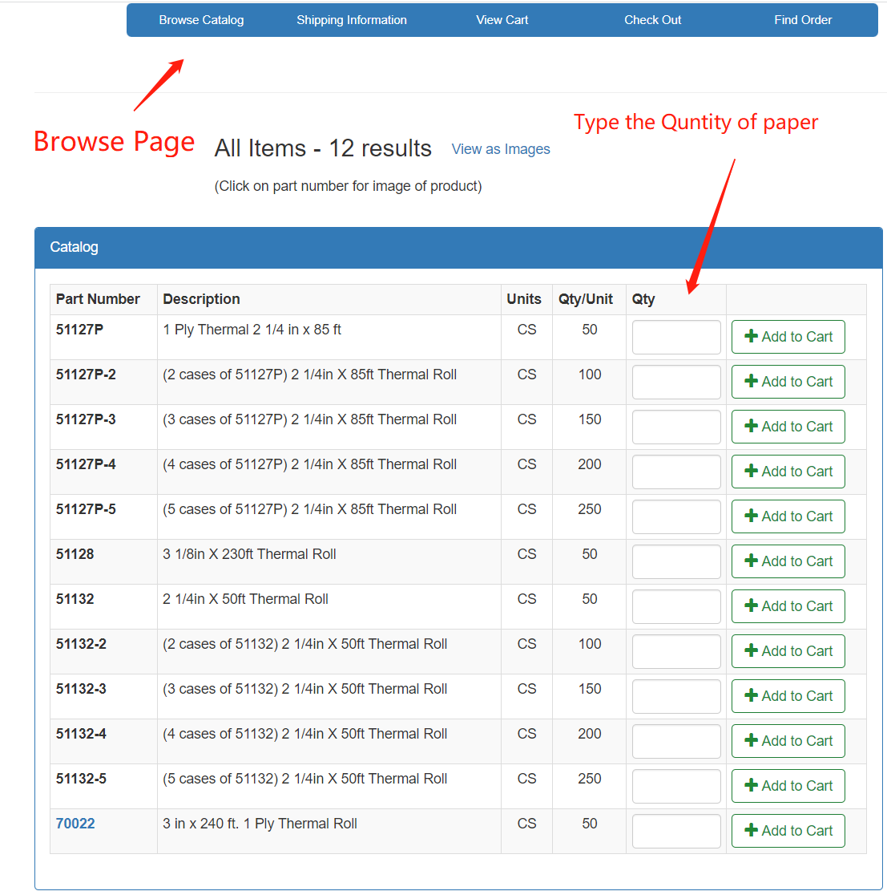

3. Open the paper order portal- *GCF shopping cart:* <https://gcfinc.com/link.asp?a=UNIVERSAL&b=ADZ4HEIH6IUk&>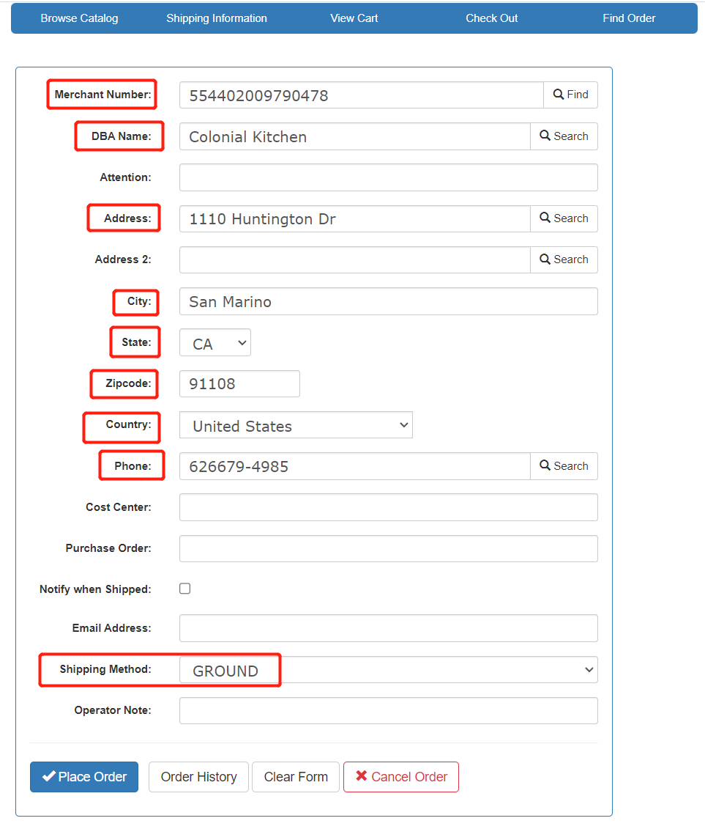

*Shipping information page

For existing customers. Please search MID and hit 

For new customers(First time order), please type all information listed in above picture.

Then click 

**Note: *Shipping method always Ground, Email can be cs@uprocessing but do not click Notify when shipped**

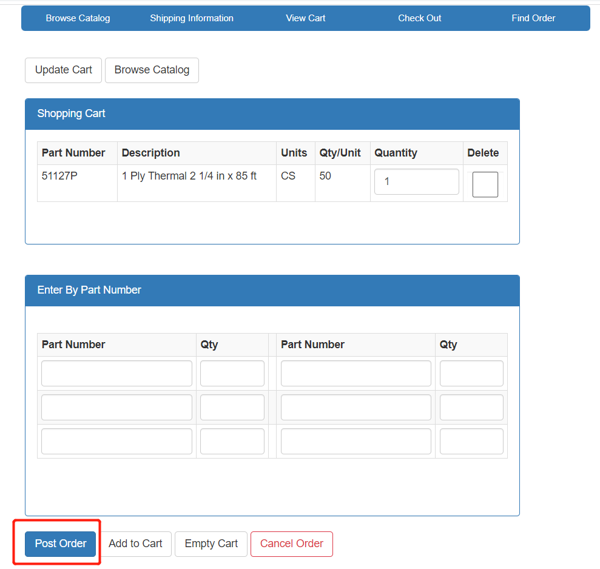

Then Post order and Close the OpenERP paper order ticket.

For tracking the History Order

1 open shipping info page.

2 search the MID,

3, Click the order history.

4 Tracking # will show up after click the order #

**Updating Notes: UP Risk Team**

From 7/9/2024 on, when there are any following change requests in our BIN by MCs via call / ticket / email, please send the email to Risk team by **risk@letsgoup.com** before taking actions.

**1. DDA change**

**2. monthly discount ->daily discount**

**3. standard funding -> NDF**

**4. add EBT**

**5. increase ticket size/ volume**

**6. DBA address change**

Once it’s approved by the Risk team, the change request can be completed.

**The Right Way to Contact a Reseller for Support.**

Reseller Account usually does not have MC to cover paper rolls and terminals.

Therefore, if a reseller's merchant contacts us for support we need to let Reseller directly.

Here are the steps

1. Find our Reseller’s contact information [Reseller Contact Information](https://docs.google.com/spreadsheets/d/14DcZQwUu-3S0LcCWQFpiQsyEDwQQS3ZkkNY14BoF6Ok/edit?gid=0#gid=0)
2. Write a formal email to reseller and CC our RM tea, rm@letsgoup.com
3. Don’t forget to CC [cs@letsgoup.com](mailto:cs@letsgoup.com)